© Australian Curriculum, Assessment and Reporting Authority (ACARA). The material is licensed under CC BY 4.0 (https://creativecommons.org/licenses/by/4.0).

Adapted from:
NSW Department of Education and Training (2008) Integrated Learning: Stage 4 (Secondary Connected Outcomes Groups), Designing a cross-curriculum unit of work handbook for schools.
CONTENTS
CONTENTS 3
ABOUT THIS RESOURCE 4
INFORMATION FOR PROJECT LEADERS 5
SUGGESTED PROCESS 7
STEP 1: DETERMINE THE SCHOOL IDENTIFIED PURPOSE 9
STEP 2: CHOOSE THE CONNECTING IDEA 11
STEP 3 (i): TARGET THE CURRICULUM 16
STEP 3 (ii): USING THE GENERAL CAPABILITIES 17
STEP 5: PLAN ASSESSMENT OF THE COMMON STUDENT TASK 19
STEP 6: PLAN TEACHING AND LEARNING ACTIVITIES 24
STEP 7: REFLECT AND EVALUATE 28
REFERENCES 29
READING 29

ABOUT THIS RESOURCE
This workbook is a practical guide for schools to use when designing a Science, Technology, Engineering and Mathematics (STEM) Connections unit of work. It has been produced in ‘workbook’ format to allow information to be recorded as your team moves through the modelled process.
It includes:
- a suggested process for school teams to follow
- activities to be completed at each step
- sample project ideas
- suggested approaches to assessment
- resources.

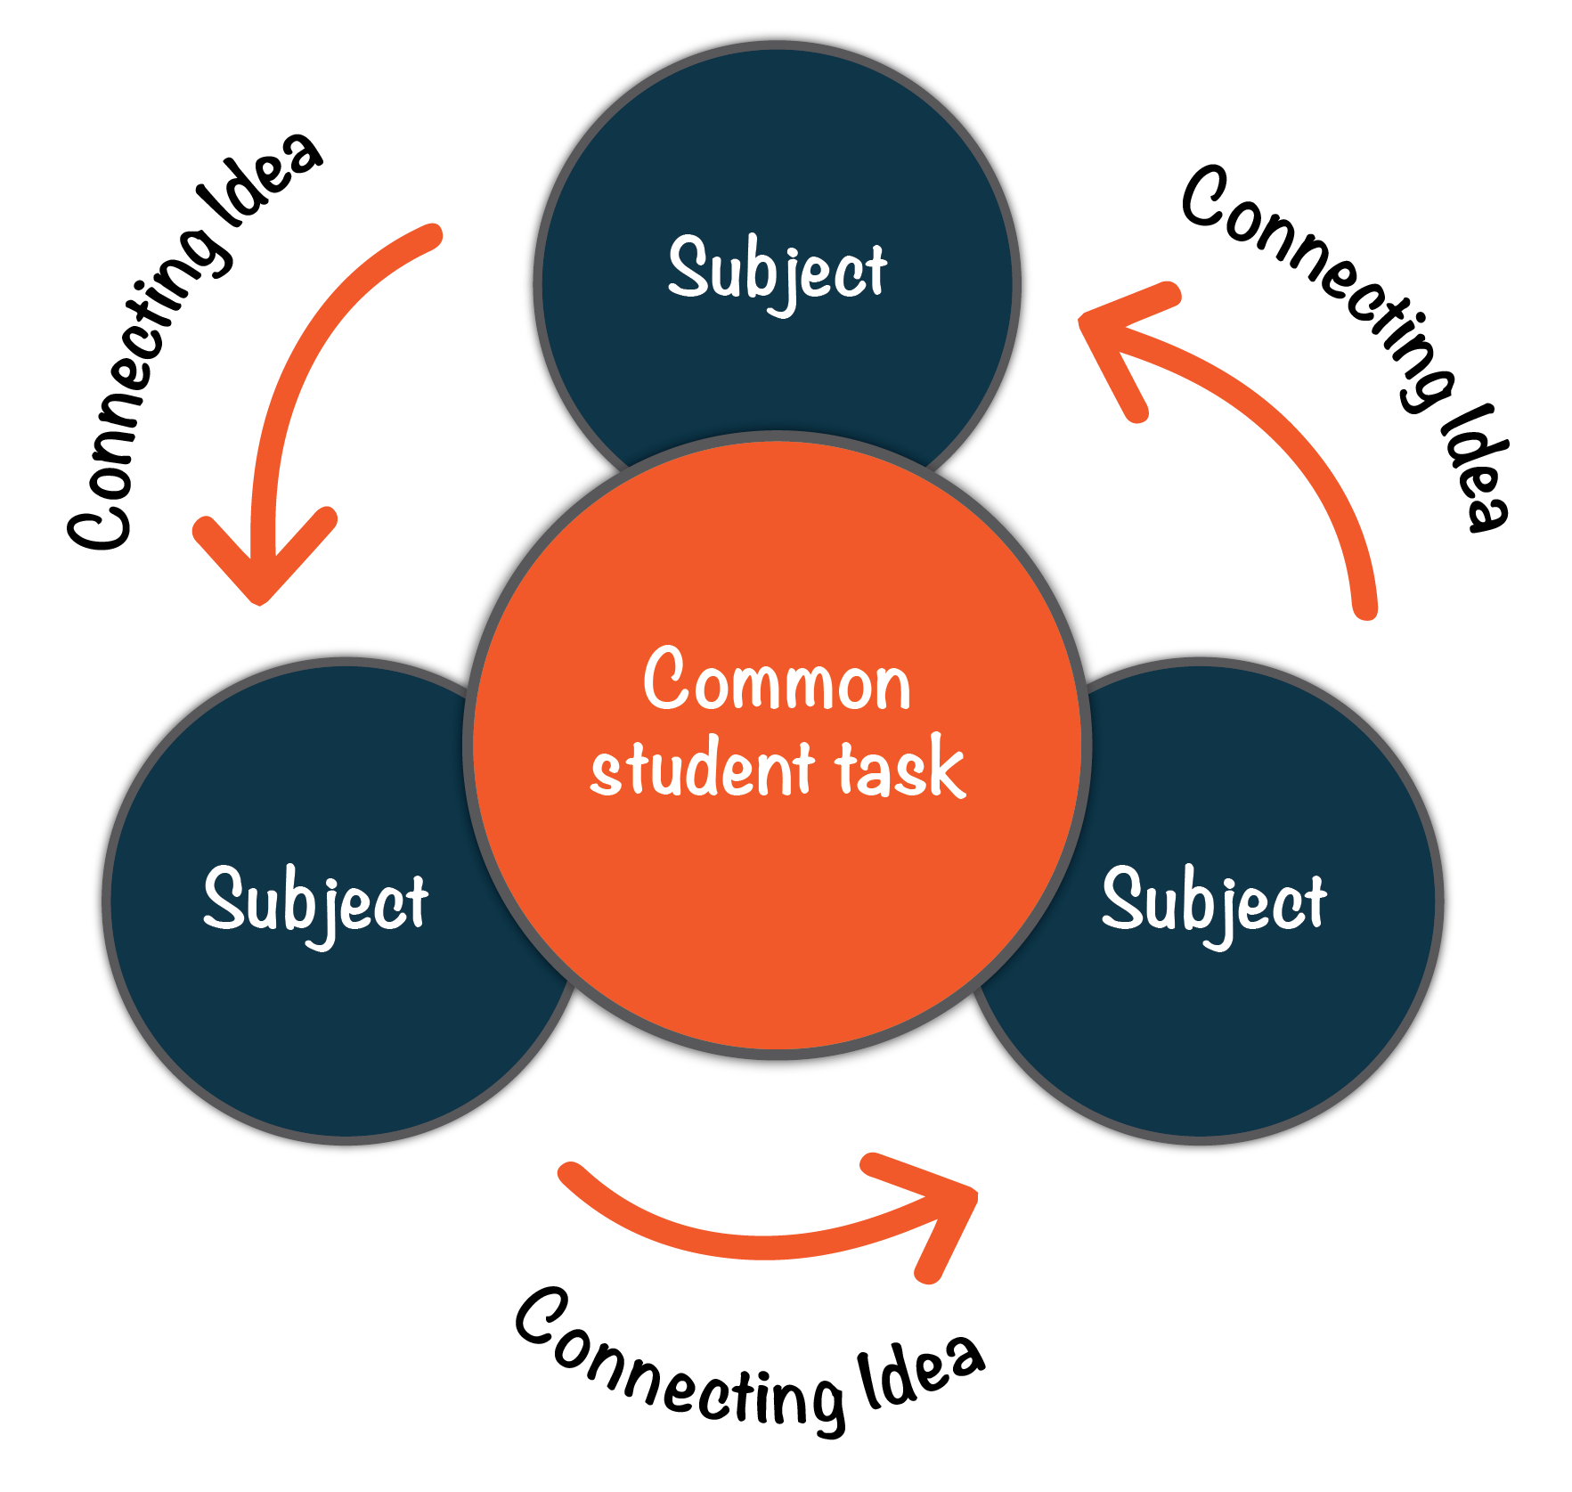

INFORMATION FOR PROJECT LEADERS
Role
The project leader will support their team by:
- providing access to data, information and resources
- maintaining regular contact with the school executive
- providing personal and public recognition and praise
- creating a climate of mutual respect and support
- developing and implementing an effective management cycle for the project.
Considerations
The following needs to be determined:
- Teachers to be involved.
- The class/classes targeted.
- The timing of the unit and the time required for designing it.
Frequently asked questions
How long should be spent planning the unit?
Two days (preferably away from school) would be ideal. Use one day to plan the bigger picture and the second day for teachers to plan teaching and learning strategies together.
How long does a unit go for?
This is up to the school and teachers involved; however, one term is a common amount of time for one project.
Which classes do we target?
A STEM Connections unit can be developed for any class from Foundation to Year 10, based on an identified need.
Can we do more than one unit in the year?
You need plenty of time to plan a different scope and sequence to the ‘norm’. Project leaders should ensure teachers are given time to plan.
Do we have to follow the planning steps in sequence?
All team members will be thinking about many steps at once; however, it is recommended to follow the suggested process, as it is based on best practice.
What if our subjects are semesterised?
This may be more relevant for secondary schools, but as you plan you may uncover various logistical problems. This might mean that the unit of work is delayed, or there will be changes to the way it is taught. That is why STEM Connections must be a school developed strategy, as each school is unique.
How will I be able to ‘fit in’ the rest of the curriculum?
This unit will take the place of what is usually taught. It will not be an addition to it. In subjects with a higher number of lessons each cycle, a proportion of time can be dedicated to the unit, with other outcomes covered in remaining lessons. There may also be changes to assessment and reporting for this class.
Do we need to meet during the term, and if so will it be in my own time?
Project leaders need to create time for the team to meet. Corridor conferences will naturally take place and there should be planned meetings to act as checkpoints along the way. These may occur before or after school, if agreed by teachers. Some schools use funds to include team meeting times in the school week.
How can I stimulate interest in this idea?
Teachers may want to analyse recent research or read about the experience of other schools in order to gain professional understanding of integrated learning. For example, ACARA’s STEM connections report and illustrations of practice could prove useful. (https://www.australiancurriculum.edu.au/resources/stem/stem-report/ )
What else needs to be considered?
Day -to-day school life needs to be taken into account when planning. This includes:
- assessment and reporting for the semester
- forward planning to invite parents and special guests to view the students’ work
- whole-school events such as camps, carnivals, and other projects running at the same time.
Which personnel can support this project?
When considering the nature of support needed for the project, a range of internal and external personnel can be helpful, including:
- teacher librarians who are well resourced to support the collaborative process and provide information literacy support to the students and staff
- support staff who have the expertise required to provide teachers with strategies for the explicit teaching of some of the identified skills
- regional support staff, such as quality teaching consultants, literacy and numeracy consultants, ICT specialists, and others who bring in particular expertise to support teaching and learning.

SUGGESTED PROCESS

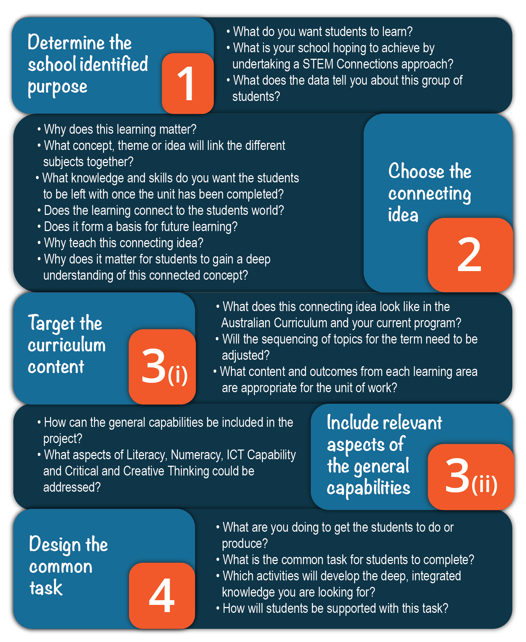

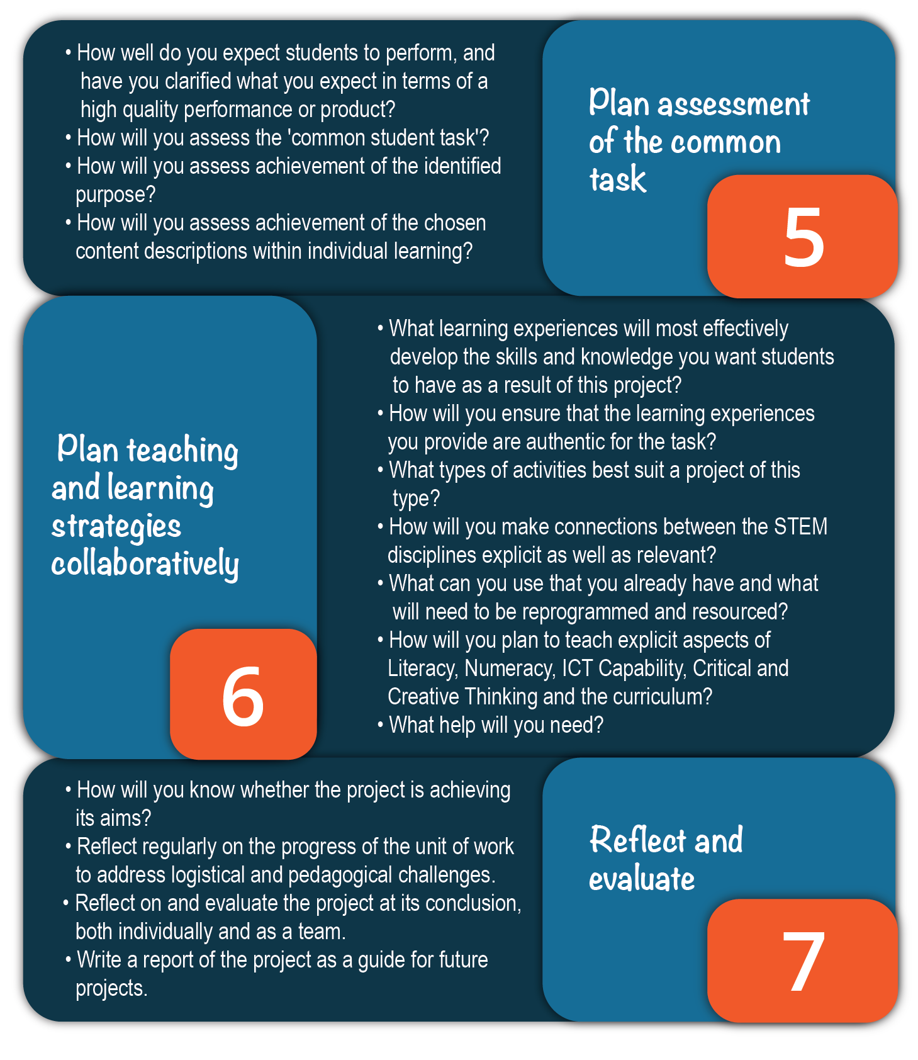

STEP 1: DETERMINE THE SCHOOL IDENTIFIED PURPOSE
What do you want students to learn?
What is your school hoping to achieve by undertaking a STEM Connections project?
A STEM Connections unit of work is an opportunity for the team to meet the complex learning needs of an identified group of students. The school identified purpose will include some or all of the elements below:
- The specific learning needs of this group of students identified by data analysis.
- The aspects of Literacy, Numeracy, ICT Capability and Critical and Creative Thinking you want to include. This is an opportunity for staff to plan to use some common approaches to teaching these skills.

Useful sources to inform purpose
- School management plan
- School environmental management plan
- Documentary evidence:
- student work samples and projects
- student voice through vodcasts
- minutes of meetings
- parent letters
- information from school teams such as learning support team, welfare team and Executive
- information from focus groups of students, parents, community members, partner primary or secondary schools.
- Different forms of data such as:
- test result analysis
- attendance and truancy rates
- school report data
- surveys of various kinds
- incident reports entered into the schools’ system.

School identified purpose: record your information below
Project leader: | Class or classes involved:
Participating teachers: | Duration/Timing of unit:
What do we know about these students?

School identified purpose
What are the specific learning needs of this group of students?

Which aspects of Literacy, Numeracy, ICT Capability and Critical and Creative Thinking do you want to include? (Review the learning continua for the targeted general capability.)

STEP 2: CHOOSE THE CONNECTING IDEA
How can we find a meaningful connection?
Complete the following activities to confirm your connecting idea, or to find one.
Activity 1
Write your answers to the following questions below.
Is there a whole-school focus that our school community is currently concerned with? For example:
- a global issue
- an essential question we want students to investigate more deeply
- cross-curriculum content (such as sustainability)
What engages our students? What are the students’ ideas and interests?

How does literacy and numeracy data inform the task design and how can it be addressed through the connecting idea?

What have students learned in previous years? What can they do?

What resources does our school community have that can be used?

What ideas, interests, and areas of expertise do we have and how do they link to curriculum?

What funds are available? Are there any pre-existing projects or funds with goals consistent with the aims of this project?

What can we focus on that would address the school identified purpose outlined above?
Some sample ideas:
- climate change
- future technologies
- justice
- globalisation
- sustainable living.

Record your connecting idea here:

Activity 2
What do you normally teach these year levels? Individual teachers complete this table using their teaching and learning program.
Term | Year________ | Year_________ | Year_________
 | Unit description: What knowledge, topics and skills would you normally teach?
1
2
3
4

Activity 3
Group summary – Where are the links?
Record information from previous activity. Discuss areas of similarity and difference.
Term | Subject: | Subject: | Subject: | Subject:
Term 1
Description of units
Term 2
Description of units
Term 3
Description of units
Term 4
Description of units

Why does this learning matter?
Activity 4
Teachers involved need to be able to articulate and answer this question on two levels:
- The broad level of the connecting idea, and why teaching it collaboratively will be of benefit to students.
- The subject level, to help teachers when they choose their teaching and learning activities. Why does this learning matter to students in my class/subject?
The connecting idea
In this exercise, you are referring to the connecting idea.
Why does this learning (the connecting idea) matter to our students? For example: why does learning within cross-curriculum priorities, e.g. ‘sustainable school and climate change’ matter to our students?

Why does this learning (the connecting idea) matter to students in my class/subject? For example: why does learning about sustainable action matter in my class/subject?

STEP 3 (i): TARGET THE CURRICULUM
What learning area content links the purpose and connecting idea?
For the connections across the curriculum to be valid, teachers choose content descriptions from their curriculum which link to the identified purpose and connecting idea and then share the information with other team members.
Type or cut and paste content descriptions (in full) onto the planning template so information can be shared between staff. Follow these guidelines:
- Only choose relevant content descriptions – it is important to be realistic and select only meaningful content.
- Ensure that they reflect the connection between the identified purpose, the connecting idea and your curriculum content.
Content description _________________ | Content description _________________
Content description _________________ | Content description _________________

STEP 3 (ii): USING THE GENERAL CAPABILITIES
How can the general capabilities be included in the project?
In this step, include the aspects of Literacy, Numeracy, ICT Capability and Critical and Creative Thinking selected in Step 1. Type or cut and paste these into the table below:
Literacy  e.g. Deliver presentations: In Foundation, students will plan and deliver short presentations. By the end of Year 10 students will plan, research, rehearse and deliver presentations on complex issues.  http://docs.acara.edu.au/resources/General_capabilities_-_LIT_-_learning_continuum.pdf | Numeracy  e.g. Interpret data displays: In Foundation, students display information using real objects and respond to questions. By the end of Year 10 students evaluate media statistics and trends.  http://docs.acara.edu.au/resources/General_capabilities_-_NUM_-_learning_continuum.pdf
ICT  e.g. Impacts of ICT in society: In Foundation, students identify how they use ICT in multiple ways. By the end of Year 10 students assess the impact of ICT in the workplace.  http://docs.acara.edu.au/resources/General_capabilities_-_ICT_-_learning_continuum.pdf | Critical and Creative Thinking  e.g. Transfer knowledge into new contexts: In Foundation, students connecting information and by Year 10, students are able to identify and plan for the transfer of knowledge to new contexts.  http://docs.acara.edu.au/resources/General_capabilities_-CCT_-_learning_continuum.pdf

STEP 4: DESIGN THE COMMON STUDENT TASK
What are we going to get students to do or produce?
The task should allow students to demonstrate deep understanding of the connecting idea; require them to make meaningful connections between different subjects; and apply the knowledge and skills identified in the original purpose. When designing the task:
- Remember, it is not necessary to design a common task through which each subject content description is assessed; that will be done by the individual class teacher or subject teacher.
- The common student task should be exciting and challenging for the students, something to celebrate and present at the end of the STEM Connections unit of work.
Check your project against the research below:
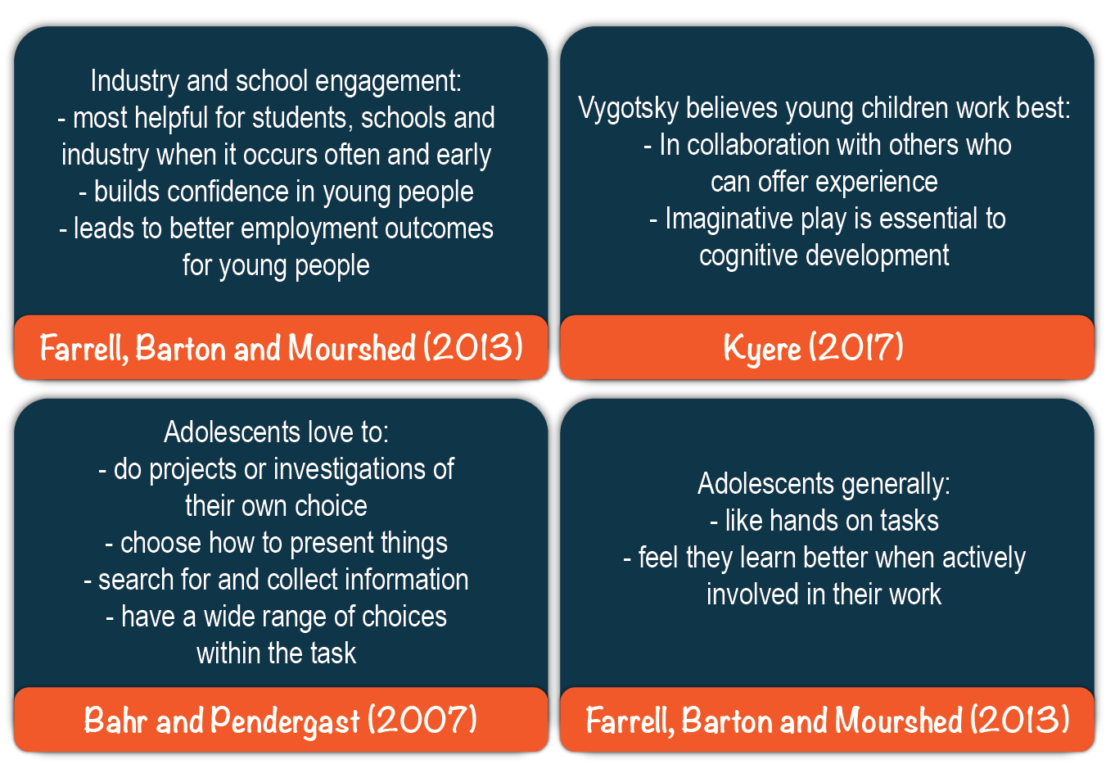
What will your students do or produce?
Record your common student task below:

Students will:

STEP 5: PLAN ASSESSMENT OF THE COMMON STUDENT TASK
What meaningful connections can be identified and assessed in some way?
Individual subject level
Teachers will plan formal and informal tasks within their own lessons as they normally would, adhering to the principles of assessment for and assessment of learning. Teachers have selected the subject content descriptions appropriate to this unit of work and will use different strategies to assess that content, such as: journals, portfolios, reports, learning logs, in-class presentations, blogs, quizzes, mind-maps, etc.
Assessing the common student task
Teachers from different subjects plan what they are going to assess in the common task, and how to communicate the criteria explicitly to students. The common student task can be assessed on a broader level, with teachers choosing to assess any elements from the identified purpose.
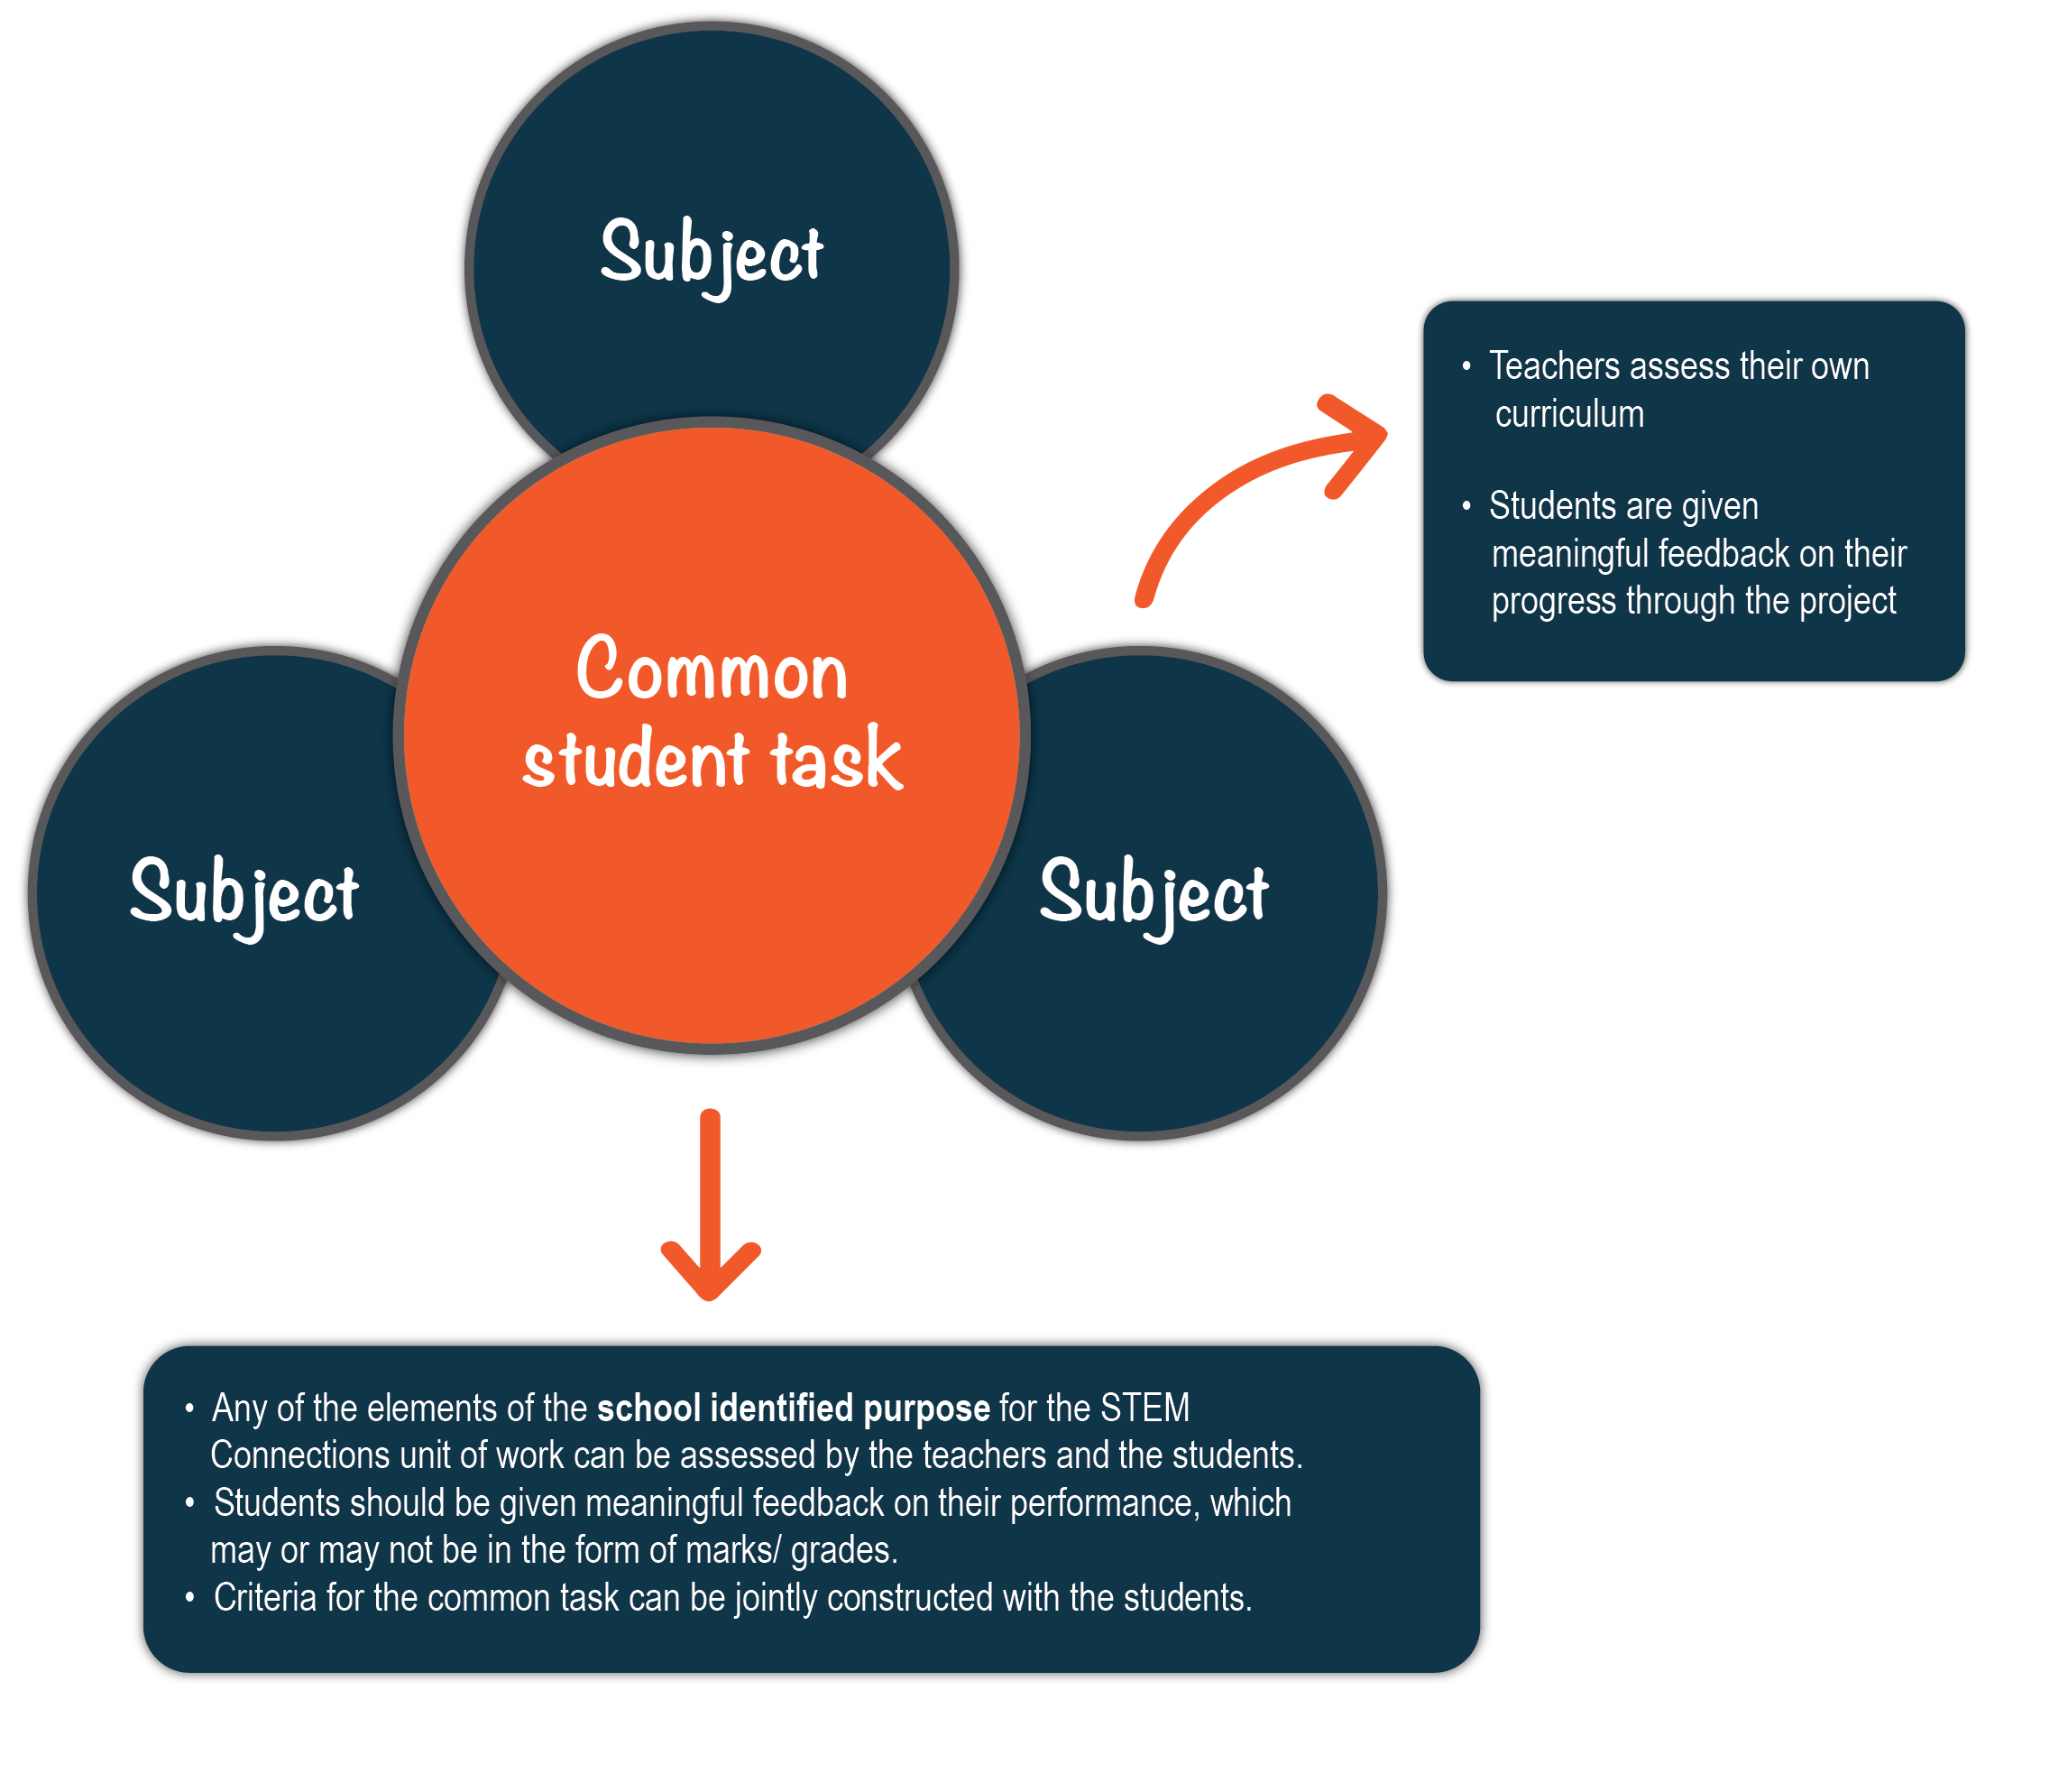

Assessing the common student task (cont’d)
Elements to be assessed can be chosen from:
- The identified purpose (Step 1) and what it is you have asked the students to do or produce
- The aspects of the capabilities (Step 3 (ii)) – the Literacy, Numeracy, ICT Capability and Critical and Creative Thinking skills students are required to demonstrate in order to complete the task.
It is up to the teachers to decide if marks, grades, levels of competence etc., are to be applied to the common student task.
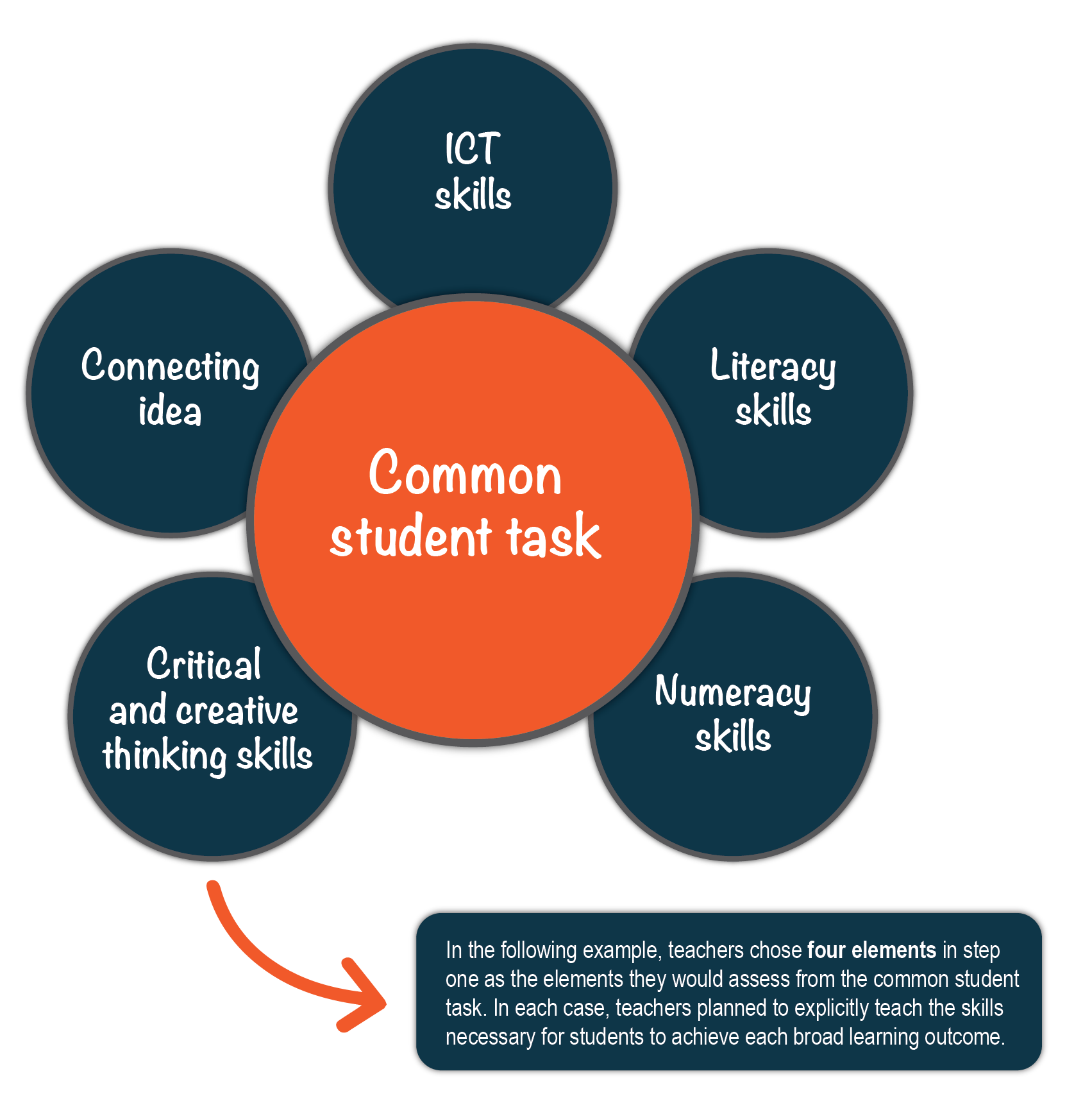

Sample (from sustainable action unit)
Outcomes chosen | What do we expect students to do? | How will this be assessed?
Access, analyse, evaluate and use information from primary and secondary sources, as well as all three subjects |  | Information and communication package displayed at the ‘expo’ day must include required information.  Will be assessed by ‘expert’ panel on the expo day.  Ask visiting students to peer assess.
Communicate ideas and information about climate change and its local effects | Give a short presentation to an expert panel. Ensure the package will inform the local community about impact of the sustainable action e.g. global warming and rising sea levels on their community. | Teachers and students construct criteria for a high-quality presentation.  An expert panel will assess the group’s work.
Work collaboratively with others to achieve individual and collective goals | Work in small groups to complete the task. | Teachers will build group-work skills through:  - scaffolded activities to encourage work in pairs  - use of talking and listening activities.  Students self-assess their own performance in the group at the end of the project.
Be productive, creative and confident in the use of technology | Design and make an information and communication package that incorporates the appropriate elements from technology. | Explicit teaching to demonstrate how to use the appropriate technology. Students given criteria in the beginning.  External panel judges student work.

Suggested ways of assessing a common student task include:
- Collaborative teacher assessment of chosen elements of the common student task using moderation.
- Moderation involves teacher collaboration to establish shared criteria of what a high-quality solution looks like and whether or not the student or group has demonstrated achievement of it.
- Teachers can jointly construct these criteria with the students.
- A panel of teachers can then assess the student performance at the end. For example: what is a high-quality presentation? Teachers can establish a consistent set of criteria to apply to the student task, and/or brainstorm with students to create explicit criteria.
- Peer assessment of chosen elements of the common student task using peer assessment guidelines. For example, Year 5 students may be given a scaffold such as the ‘ladder of feedback’ from Harvard University, Year 8 students can be briefed on the criteria for a high-quality presentation, view Year 9 or 10 work, then assess against the criteria.
- Student self-assessment of chosen elements of the common student task such as their:
- deep understanding of the connecting idea
- performance as part of a group, for example students can use a log book or wiki for the duration of the student task and reflect on the connecting idea throughout the project.

Complete the table below for your assessment of the common task
Element of the common task we want to assess | What do we expect students to do? | How well do we expect them to do it? | How will we assess it?

STEP 6: PLAN TEACHING AND LEARNING ACTIVITIES
What learning experiences will develop the skills and knowledge you want students to have?
This section should:
- list the activities in which students will engage
- show the sequence of activities you will be getting the students to do in class. Include checkpoints along the way to assess students’ progress.
Considerations
- Include activities in your lessons which develop the identified aspects of the subject and the general capabilities.
- Model how to organise and plan tasks that extend over a long period of time for students.
- Use what works for this unit from your existing program, discard what does not.
- Include learning experiences that will enable students to demonstrate the targeted outcomes.
- Include teaching and learning experiences that will allow students to DO, rather than be told.
- Determine what resources you already have or will need.
- What room changes and access to technology will you require?
- What support and professional development do you need and how will you access it?

Use the table on the next page to record your plan.

Planning
Detail from achievement standards | Learning experiences | Assessment for learning
Select and enter these directly from your curriculum. Add extra detail relevant to the connecting idea and common task. | What do you want students to do? List the activities students will engage in. Show the sequence of activities. Include elements required for students to complete the task. | Plan formal and informal ways to evaluate student achievement of outcomes and skills.

Planning to teach aspects of Literacy, Numeracy, ICT Capability and Critical and Creative Thinking
The table below can be used to plan for the explicit teaching of these aspects. (Cut and paste most of this from the previous step.)
Aspect | What do we expect students to do? | How well do we expect them to do? | Explicit teaching strategies
Literacy
Numeracy
ICT Capability
Critical and Creative Thinking
Term planner
Prior to teaching the unit, teachers should map out what is happening for the whole term. This will allow the team to:
- plan common activities such as fieldwork
- find areas of overlap
- allow for major school events
- plan for the presentation of the common task.
Use the table below to plan the whole sequence.
Week | Subject | Subject | Subject | Subject
1
2
3
4
5
6
7
8
9
10
11
STEP 7: REFLECT AND EVALUATE
How will you know whether the project is achieving its aims?
Project leaders should plan time for effective reflection and evaluation during and after the unit of work.
During the unit, teachers will want to talk about how things are progressing, how certain students are developing, and to share ideas about the common student task.
After the unit, teams should re-visit their identified purpose (Step 1) and think about how to evaluate it. For example, if improved student engagement was one identified purpose, how could you evaluate this? Feedback should be communicated to the school executive.
Before you begin teaching:
- What aspects of the unit should be pre-and post-tested? E.g. if necessary, aspects of literacy and numeracy can be assessed before and after the project; an attitudinal survey can provide helpful qualitative feedback.
- Are there any surveys, learning journals, or other evaluation methods which should be produced prior to teaching?
Some questions to prompt discussion at the end of the unit include:
- Was deep understanding of the connecting idea demonstrated by the students? Were assessment methods effective in determining this?
- How well did students achieve in learning areas and on the common task?
Sources of information
- Teachers reflect on the process itself.
- Students self-reflect about what they have learned about the connecting idea and other identified aims.
- Teachers can attend colleagues’ classes to view lessons that have been jointly prepared, with the aim of refining them for later use with other classes.
- Project leader reflects on the whole project, and feedback about their own effectiveness.
- Parent and student can provide feedback through surveys.

Note: More formal evaluation methods may be required if the school is reporting to an external organisation.

REFERENCES
Australian, Curriculum, Assessment, Reporting Authority (ACARA). (2017). General Capabilities. Retrieved from Australian Curriculum: https://www.australiancurriculum.edu.au/f-10-curriculum/general-capabilities/
Education Council. (2015). National STEM School Education Strategy 2016–2026. Retrieved from Education Council: http://www.educationcouncil.edu.au/EC-Reports-and-Publications.aspx
English, L. D. (2016). STEM education K-12: perspectives on integration. International Journal of STEM Education, 6-13.
Reading
Education Council. (2015). National STEM School Education Strategy 2016 - 2026. Retrieved from Education Council: http://www.educationcouncil.edu.au/EC-Reports-and-Publications.aspx
English, L. D. (2016). STEM education K-12: perspectives on integration. International Journal of STEM Education, 6-13.
Larmer, J. Mergendoller, J., Boss, S. (2015). Setting the Standard for Project-Based Learning: A Proven Approach to Rigorous Classroom Instruction. ASCD. Alexandria.
Mann, A. (2014). ‘It’s who you meet: why employer contacts at school make a difference to the employment prospects of young adults’ in Education and Employers. Retrieved from: https://www.educationandemployers.org/wp-content/uploads/2014/06/its_who_you_meet_final_26_06_12.pdf
Marginson, S., Tytler, R., Freeman, B., Roberts, K. (2013). STEM: Country Comparisons. Report for the Australian Council of Learned Academies. Retrieved from: http://acola.org.au/PDF/SAF02Consultants/SAF02_STEM_%20FINAL.pdf
National Academy of Engineering and National Research Council 2014 STEM Integration in K–12 Education: Status, Prospects and an Agenda for Research. Retrieved from: www.nap.edu/catalog/18612/stem-integration-in-k12-education-status-prospects-and-an-agenda
P21 (2014). Partnership for 21st Century Skills. Retrieved from: www.p21.org
Scientix, the Community for Science Education in Europe (2014). Building a STEM education community in Europe. Retrieved from: https://www.youtube.com/watch?v=qmidAbl43wA
STEMNET Science, Technology, Engineering and Mathematics Network. (2014) Retrieved from: https://www.stem.org.uk/elibrary/collection/2910
Strimel, G. (2014). ‘Engineering by Design: Preparing STEM Teachers for the 21st Century. PATT conference proceedings, Technology education for the future: a play on sustainability.

