Worawa Aboriginal College IOP
Supporting Documentation
Tony Birch
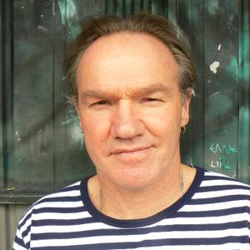
Write about what you know, and what do you know better than your own secrets? Raymond Carver

Intro
Where do we find the story?
Not enough Indigenous young women tell their story…what does this mean for us?
Reciprocal story telling
Read for enjoyment, listen for enjoyment

Subjects
Who has a scar caused by accidents? Who has a broken bone?
Our families
Who in your family is important to you?
My three minute life story – a person in your family
What did you bring from home to Worawa?

Characters
The people in our stories
Telling stories of people who are sometimes forgotten about

Emotions and Feelings
The storyteller – Syrian children greeted by a Tarboush who tells them stories of their home land.

Places
Where do you like to hang out? What does it feel like, taste like, smell like?

Inspiration
Tony read from ‘Blood’
Three minutes about my big sister
My grandma
Movie ‘Afterlife’…a 3 minute film about your life
The broken angel…statue in the cemetery

Writing Exercises
- Flash or Micro Fiction
Fill in this space with words, a story, poetry, song words…check the sample first

- Suitcases by Chi Vu …What can you take?
- Sketch in words a face, a place
- Speech Bubbles or animation…dialogue
- Photograph…what is she thinking?
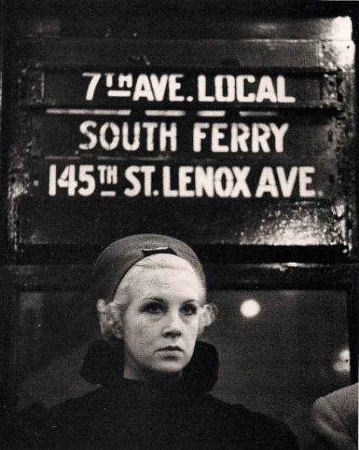
References
http://josephinerowe.com/index.html
http://www.poetryinternationalweb.net/pi/site/poet/item/19572/15/Samuel-Wagan-Watson
https://www.newsouthbooks.com.au/books/songs-sound-blood/
https://scribepublications.com.au/books-authors/books/shadowboxing
http://www.harpercollins.com.au/9780207197321/
https://en.wikipedia.org/wiki/List_of_Indigenous_Australian_writers
https://www.magabala.com/
http://omarbinmusa.blogspot.com.au/

Events
Feb - http://blakandbright.com.au/
https://writersvictoria.org.au/support/young-writers
http://www.emergingwritersfestival.org.au/

Therapeutic Creative Writing
Prompt
My grandma used to stroke my hair, pushing it behind my ear as she spoke to me. It was annoying because it tickled but after she died, I missed her doing it. Now as an older woman, I do the same to children in the family.
Task
Write a similar recollection and develop this into a story that tells us something about how you feel.

