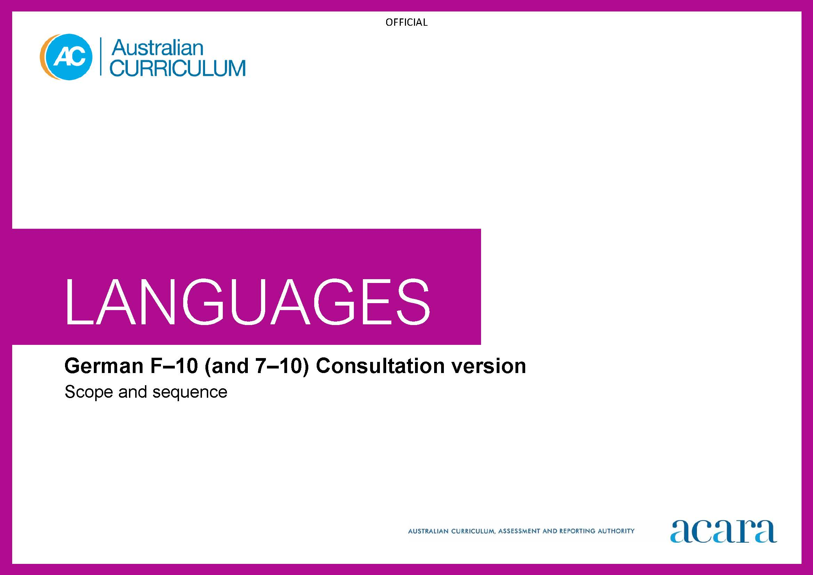

Copyright and Terms of Use Statement
© Australian Curriculum, Assessment and Reporting Authority 2022
The material published in this work is subject to copyright pursuant to the Copyright Act 1968 (Cth) and is owned by the Australian Curriculum, Assessment and Reporting Authority (ACARA) (except to the extent that copyright is held by another party, as indicated).
The viewing, downloading, displaying, printing, reproducing (such as by making photocopies) and distributing of these materials is permitted only to the extent permitted by, and is subject to the conditions imposed by, the terms and conditions of using the ACARA website (see, especially, clauses 2, 3 and 4 of those terms and conditions). The terms and conditions can be viewed at https://www.acara.edu.au/contact-us/copyright

Foundation | Years 1–2
Achievement standard
By the end of the Foundation year, students use play and imagination to interact and create German texts, with support. They identify that German and English look and sound different. They recognise that there are languages and cultures as well as their own, and that aspects of language and culture contribute to their own and others’ cultural identity. | By the end of Year 2, students use German language to interact and share information related to the classroom and themselves. They use cues to respond to questions and instructions, and use simple formulaic language. They locate and convey key items of information in texts using non-verbal, visual and contextual cues to help make meaning. They use familiar words and modelled language to create texts.  Students imitate the sounds and rhythms of German and demonstrate understanding that German has conventions and rules for non-verbal communication, pronunciation and writing. They give examples of similarities and differences between some features of German and English. They understand that language is connected with culture, and notice how this is reflected in their own language(s) and culture(s).

Content descriptions
 | Strand: Communicating meaning in German
 | Sub-strand: Interacting in German
with support, recognise and communicate meaning in German  AC9LGF01 | recognise and respond to modelled classroom-related greetings, instructions and routines; and personal introductions  AC9LG2C01
explore, with support, language features of German noticing similarities and differences between German and English  AC9LGF02 | participate in a range of guided, play-based language activities using formulaic expressions, visual and spoken cues  AC9LG2C02
explore connections between language and culture
AC9LGF03
 | Sub-strand: Mediating meaning in and between languages

locate, with support, key information in familiar texts, and respond using gestures, images, words and formulaic phrases

AC9LG2C03

notice that language carries cultural meaning in classroom-related greetings, introductions, instructions and routines

AC9LG2C04
 | Sub-strand: Creating text in German

use words, familiar phrases and modelled language to create spoken, written and multimodal texts

AC9LG2C05

Strand: Understanding language and culture
Sub-strand: Understanding systems of language
recognise and imitate the sounds and rhythms of German

AC9LG2U01

recognise that the Roman alphabet is used to construct meaning in texts in German

AC9LG2U02

notice that German has features that may be similar to or different from English

AC9LG2U03
Sub-strand: Understanding the interrelationship of language and culture

notice that people use language in ways that reflect cultural practices

AC9LG2U04

Years 3–4 | Years 5–6
Achievement standard
By the end of Year 4, students use German language to initiate structured interactions to share information related to the classroom and their personal world. They use modelled language to participate in spoken and written activities that involve planning. They locate and respond to key items of information in texts using strategies to help interpret and convey meaning in familiar contexts. They use modelled language and basic syntax to create texts.  Students imitate sound combinations and rhythms of German language. They demonstrate understanding that German has non-verbal, spoken and written language conventions and rules to create and make meaning. They recognise that some terms have cultural meanings. They identify patterns in German and make comparisons between German and English. They understand that the German language is connected with culture, and identify how this is reflected in their own language(s) and culture(s). | By the end of Year 6, students initiate and use strategies to maintain interactions in German language that are related to their immediate environment. They use appropriate sound combinations, intonation and rhythm in spoken texts. They collaborate in spoken and written activities that involve the language of planning and problem-solving to share information, ideas and preferences. They use strategies to locate and interpret information and ideas in texts, and demonstrate understanding by responding in German or English, adjusting their response to context, purpose and audience. They create texts, selecting and using a variety of vocabulary and sentence structures to suit context. They sequence information and ideas, and use conventions appropriate to text type.  Students apply rules for pronunciation and intonation, spelling and punctuation, and modelled structures, when creating and responding in German. They compare language structures and features in German and English, using some metalanguage. They show understanding of how some language reflects cultural practices and consider how this is reflected in their own language(s), culture(s) and identity.

Content descriptions
Strand: Communicating meaning in German
Sub-strand: Interacting in German
initiate exchanges and respond to modelled questions about self, others, and classroom environment, using formulaic expressions  AC9LG4C01 | initiate and sustain modelled exchanges in familiar contexts related to students’ personal world and school environment  AC9LG6C01
participate in activities that involve planning with others, using a range of familiar phrases and modelled structures  AC9LG4C02 | participate in activities that involve planning and negotiating with others, using language that expresses information, preferences and ideas  AC9LG6C02
Sub-strand: Mediating meaning in and between languages
locate and respond to key information related to familiar content obtained from spoken, written and multimodal texts  AC9LG4C03 | locate and process information and ideas in a range of spoken, written and multimodal texts, and respond in different ways to suit purpose  AC9LG6C03
develop strategies to comprehend and adjust German language in familiar contexts to convey cultural meaning  AC9LG4C04 | apply strategies to interpret and convey meaning in German language in familiar non-verbal, spoken and written cultural contexts  AC9LG6C04
Sub-strand: Creating text in German
create and present informative and imaginative spoken, written and multimodal texts using formulaic expressions, simple phrases and sentences and modelled textual conventions  AC9LG4C05 | create and present a range of informative and imaginative spoken, written and multimodal texts using a variety of modelled sentence structures to sequence information and ideas, and conventions appropriate to text type  AC9LG6C05

Strand: Understanding language and culture
Sub-strand: Understanding systems of language
recognise and use modelled combinations of sounds, pronunciation and intonation patterns of German to form words and phrases  AC9LG4U01 | apply knowledge of combinations of sounds, syllables, pronunciation and intonation patterns to develop fluency and rhythm to known words and phrases  AC9LG6U01
recognise German language conventions, grammatical structures and basic syntax in familiar texts and contexts  AC9LG4U02 | use knowledge of modelled grammatical structures and formulaic expressions to compose and respond to texts using appropriate punctuation and textual conventions  AC9LG6U02
recognise familiar German language features and compare with those of English, in known contexts  AC9LG4U03 | compare some German language structures and features with those of English, using some familiar metalanguage  AC9LG6U03
Sub-strand: Understanding the interrelationship of language and culture
identify connections between German language and cultural practices  AC9LG4U04 | recognise that language reflects cultural practices, values and identity, and that this impacts on non-verbal and verbal communication  AC9LG6U04

Years 7–8 (F–10) | Years 9–10 (F–10)
Achievement standard
By the end of Year 8, students initiate and maintain interactions in German language in familiar and some unfamiliar contexts related to a range of interests and experiences. They use German to collaborate and problem-solve, and adjust language in response to others. They interpret information, ideas and opinions in texts. They demonstrate understanding of similarities and differences between languages, in both familiar and some unfamiliar cultural contexts, by adjusting and reorganising responses. They select and use vocabulary, sentence structures and expressions to create texts.  Students apply the conventions of spoken German to develop fluency. They demonstrate understanding that spoken, written and multimodal texts use different language conventions, structures and features to convey meaning. They comment on structures and features of German text, using metalanguage. They reflect on how the German language, culture and identity are interconnected, and compare this with their own language(s), culture(s) and identity. | By the end of Year 10, students contribute to and extend interactions in German language in increasingly unfamiliar contexts related to a wide range of interests and issues. They interpret texts by evaluating and synthesising information, ideas and perspectives. They show understanding of how features of language can be used to influence audience response. They create texts, selecting and manipulating language for a range of contexts, purposes and audiences. They apply and use complex sentences and structures to create and respond to spoken and written texts. They use a variety of tenses to sequence events and use language devices to enhance meaning and cohesion.  Students incorporate the features and conventions of spoken German to extend fluency. They demonstrate understanding of the conventions of spoken and written texts and the connections between them. They apply knowledge of language structures and features to make and predict meaning. They support analysis of German texts, using metalanguage. They reflect on their own cultural perspectives and identity, and draw on their experience of learning German, to evaluate how this learning influences their ideas and ways of communicating.

Content descriptions
Strand: Communicating meaning in German
Sub-strand: Interacting in German
initiate and sustain exchanges in familiar and some unfamiliar contexts related to students’ experiences, feelings and views, adjusting their language in response to others  AC9LG8C01 | initiate, sustain and extend exchanges in familiar and unfamiliar contexts related to students’ own and others’ experiences of the world, adjusting their language in response to others  AC9LG10C01
collaborate in activities that involve the language of transaction, negotiation and problem-solving to plan projects and events  AC9LG8C02 | contribute to discussions that involve diverse views to negotiate outcomes, address issues and compare experiences  AC9LG10C02
Sub-strand: Mediating meaning in and between languages
interpret information, ideas and opinions in a range of spoken, written and multimodal texts, and respond appropriately to cultural context, purpose and audience  AC9LG8C03 | evaluate and synthesise information, ideas and perspectives in a broad range of spoken, written and multimodal texts and respond appropriately to cultural context, purpose and audience  AC9LG10C03
interpret and adjust non-verbal, spoken and written language to convey meaning in German language in familiar and some unfamiliar cultural contexts  AC9LG8C04 | interpret and translate non-verbal, spoken and written interactions and texts to convey meaning and intercultural understanding in familiar and unfamiliar contexts  AC9LG10C04
Sub-strand: Creating text in German
create and present spoken, written and multimodal, informative and imaginative texts for specific purposes, selecting vocabulary, expressions, grammatical structures, features and conventions appropriate to text type and context  AC9LG8C05 | create and present informative and imaginative texts for diverse contexts and purposes, selecting vocabulary, expressions, grammatical structures and a range of features and conventions to engage different audiences  AC9LG10C05

Strand: Understanding language and culture
Sub-strand: Understanding systems of language
apply knowledge of conventions of spoken German to enhance fluency, and to respond to and create texts in familiar and some unfamiliar contexts  AC9LG8U01 | apply features and conventions of spoken German to extend fluency in responding to and creating texts in familiar and unfamiliar contexts  AC9LG10U01
apply understanding of grammatical structures and expressions to compose and respond to texts  AC9LG8U02 | apply knowledge of grammatical structures to predict meaning and compose texts that contain some complex structures and ideas  AC9LG10U02
reflect on similarities and differences between German and English language structures and features, using metalanguage  AC9LG8U03 | reflect on and evaluate German texts, using metalanguage to analyse language structures and features  AC9LG10U03
Sub-strand: Understanding the interrelationship of language and culture
reflect on and explain how identity is shaped by language(s), culture(s), beliefs, attitudes  AC9LG8U04 | reflect on and evaluate how identity is shaped by language(s), culture(s), beliefs, attitudes and values and how these affect ways of communicating  AC9LG10U04

Years 7–8 (Year 7 entry) | Years 9–10 (Year 7 entry)
Achievement standard
By the end of Year 8, students use German language to interact and collaborate with others, and to share information and plan activities in familiar contexts. They respond to others’ contributions, and recognise familiar gestures, questions and instructions in exchanges. They recognise relationships between spoken and written forms. They locate and respond to information in texts and use non-verbal, visual and contextual cues to help make meaning. They respond in German or English, and demonstrate understanding of context, purpose and audience in texts. They use familiar language, and modelled sentence and grammatical structures to create texts, and demonstrate understanding of how some language reflects cultural practices.  Students approximate German sound patterns, intonation and rhythms, and demonstrate understanding that German has conventions and rules for non-verbal, spoken and written communication. They comment on aspects of German and English language structures and features, using metalanguage. They demonstrate awareness that the German language is connected with culture and identity, and that this is reflected in their own language(s), culture(s) and identity. | By the end of Year 10, students initiate and sustain German language to exchange and compare ideas and experiences about their own and others’ personal world. They communicate using non-verbal, spoken and written language to collaborate, plan and reflect on activities and events. They interpret and analyse information and ideas in texts and demonstrate understanding of different perspectives. They synthesise information and respond in German or English, adjusting language to convey meaning and to suit context, purpose and audience. They use structures and features of spoken and written German to create texts.  Students apply features of the German sound system to enhance fluency and demonstrate understanding of the sound system in spoken exchanges. They select and apply knowledge of language conventions, structures and features to interact, make meaning and create texts. They support discussion of structures and features of texts, using metalanguage. They reflect on their own language use and cultural identity, and draw on their experience of learning German, to discuss how this learning influences their ideas and ways of communicating.

Content descriptions
Strand: Communicating meaning in German
Sub-strand: Interacting in German
interact with others using modelled language to exchange information in familiar contexts about self and personal world  AC9LG8EC01 | initiate and sustain interactions in familiar and some unfamiliar contexts to exchange ideas, experiences and opinions about their own and others’ personal world  AC9LG10EC01
develop language to interact in exchanges, routines, tasks and responsibilities related to classroom and interests  AC9LG8EC02 | use German language in exchanges to question, offer opinions and compare and discuss ideas  AC9LG10EC02
engage in modelled non-verbal, spoken and written exchanges with peers to organise activities relating to daily life and school environment  AC9LG8EC03 | use non-verbal, spoken and written exchanges to discuss, plan and reflect on activities, events and experiences with peers  AC9LG10EC03
Sub-strand: Mediating meaning in and between languages
locate and process information and ideas in familiar spoken, written and multimodal texts, responding in ways appropriate to cultural context, purpose and audience  AC9LG8EC04 | interpret information, ideas and perspectives in a wide range of spoken, written and multimodal texts and respond appropriately to cultural context, purpose and audience  AC9LG10EC04
develop and begin to apply strategies to interpret, translate and convey meaning in German in familiar contexts  AC9LG8EC05 | apply strategies to interpret and translate non-verbal, spoken and written interactions and texts to convey meaning and intercultural understanding in familiar and unfamiliar contexts  AC9LG10EC05

Sub-strand: Creating text in German
create spoken, written and multimodal, informative and imaginative texts using appropriate vocabulary, expressions, grammatical structures, and some textual conventions  AC9LG8EC06 | create spoken, written and multimodal, informative and imaginative texts, selecting vocabulary, expressions, grammatical structures and textual conventions for familiar and some unfamiliar contexts and purposes, to engage different audiences  AC9LG10EC06

Strand: Understanding language and culture
Sub-strand: Understanding systems of language
recognise and use features of the German sound system, including pitch, rhythm, stress, pronunciation and intonation, and demonstrate understanding of how these are represented in familiar contexts  AC9LG8EU01 | apply features of the German sound system, including pitch, rhythm, stress, pronunciation and intonation, and show how these are represented in familiar and some unfamiliar contexts  AC9LG10EU01
develop knowledge of, and use structures and features of, the German grammatical and writing systems to understand and create spoken, written and multimodal texts  AC9LG8EU02 | select and use structures and features of the German grammatical and writing systems to enhance meaning and create spoken, written and multimodal texts  AC9LG10EU02
compare German language structures and features with English, using familiar metalanguage  AC9LG8EU03 | reflect on and evaluate German texts, using metalanguage to discuss language structures and features  AC9LG10EU03
Sub-strand: Understanding the interrelationship of language and culture
recognise how identity is shaped by language(s), culture(s), beliefs, attitudes and values  AC9LG8EU04 | reflect on and explain how identity is shaped by language(s), culture(s), beliefs, attitudes and values and how these affect ways of communicating  AC9LG10EU04

