Thank you for giving your time to provide feedback on the new Australian Curriculum, Version 9.0 website.

ACARA is continuing to design and develop new features to further enhance the website, to improve the user experience and to allow our stakeholders to get the most out of the Australian Curriculum.

This word version is to provide you with the questions so you can have the opportunity to plan your responses. Please provide all answers through our online survey. The survey will take approximately 35–45 minutes. Please feel free to provide as much detail as possible when prompted, as any information we receive will help ACARA to plan and prioritise our future development work.

We really appreciate your time and feedback.

V9.0 Website survey questions

Section 1: Background information questions
1. In what state or territory are you based?
- Australian Capital Territory
- New South Wales
- Northern Territory
- Queensland
- South Australia
- Tasmania
- Victoria
- Western Australia
- National

2. What category best describes you?
- Primary teacher
- Secondary teacher
- F–12 teacher
- School leader – Primary
- School leader – Secondary
- School leader – F–12
- Academic
- Parent
- Student
- Employer / Business
- Other (please specify) ________________________

3. In what sector is your school?
- Government
- Catholic
- Independent
- Not applicable

4. What best describes your school's location?
- Metropolitan
- Regional
- Remote
- Not applicable

5. How familiar are you with the Australian Curriculum, Version 8.4 website?
Never viewed the site | Had a brief look 1 or 2 times | Have used the site a few times but not extensively | Am reasonably familiar with the site | Am very familiar and have used the site regularly
¨ | ¨ | ¨ | ¨ | ¨

6. How familiar are you with the Australian Curriculum, Version 9.0 website?
Never viewed the site | Had a brief look 1 or 2 times | Have used the site a few times but not extensively | Am reasonably familiar with the site | Am very familiar and have used the site regularly
¨ | ¨ | ¨ | ¨ | ¨

Section 2: Learning area selector tool (Quick select) – single subject, multiple year levels
We want to test the functionality of the website. For the following tasks, you will need to undertake some actions on the Version 9.0 Australian Curriculum website https://v9.australiancurriculum.edu.au/.
7. Using the default Quick select functionality of the learning area selector tool under the F–10 Curriculum menu, navigate to Science for Foundation to Year 6.
How easy was it to use the selector tool?
Very easy | Somewhat easy | Somewhat difficult | Very difficult
¨ | ¨ | ¨ | ¨

8. When you first arrive on the Science page selected above, you will get a drop-down box for “Understand this learning area” – see the screenshot below. How would you interact with this drop-down box?
Click on the "Understand Science" button to read background information. | Close the drop-down box.
¨ | ¨

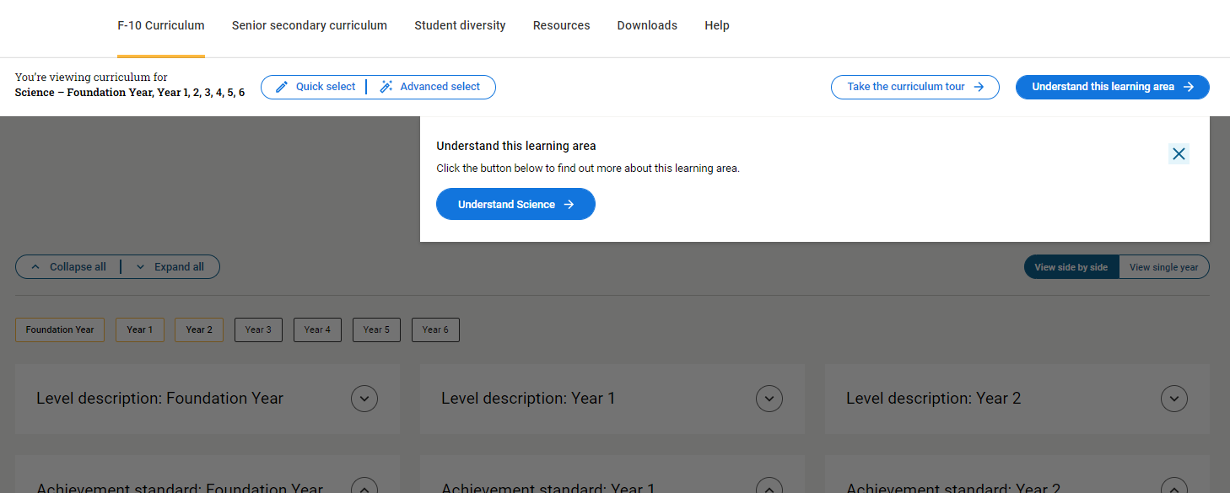
9. This drop-down box displays each time you navigate to the curriculum. Would you want to see this box each time?
Yes | No
¨ | ¨
Please explain why or why not.

Section 3: Learning area selector tool (Quick select) – multiple subjects, single year level
10 .Using the default Quick select functionality of the selector tool under the F–10 Curriculum menu, navigate to English, Mathematics and Science for Year 6.
How easy was it to use the selector tool?
Very easy | Somewhat easy | Somewhat difficult | Very difficult
¨ | ¨ | ¨ | ¨

11. Was the curriculum content you navigated to what you expected to find?
Yes | No
¨ | ¨
If no, please explain why not.

Section 4: Selector tool – general capabilities and cross-curriculum priorities
12. From the F–10 Curriculum menu, navigate to the Digital Literacy general capability.
How easy was it to use the selector tool?
Very easy | Somewhat easy | Somewhat difficult | Very difficult
¨ | ¨ | ¨ | ¨

13. Was the curriculum content you navigated to what you expected to find?
Yes | No
¨ | ¨
If no, please explain why not.

14. From the F–10 Curriculum menu, navigate to the Aboriginal and Torres Strait Islander Histories and Cultures cross-curriculum priority.
How easy was it to use the selector tool?
Very easy | Somewhat easy | Somewhat difficult | Very difficult
¨ | ¨ | ¨ | ¨

Section 5: Selector tool (Advanced select) – learning areas
15. Go to the learning area selector tool under the F–10 Curriculum menu and choose the Advanced select option (see screenshot below). Make the relevant selections to navigate to a specific strand within Science for Foundation to Year 6, and submit your selection.
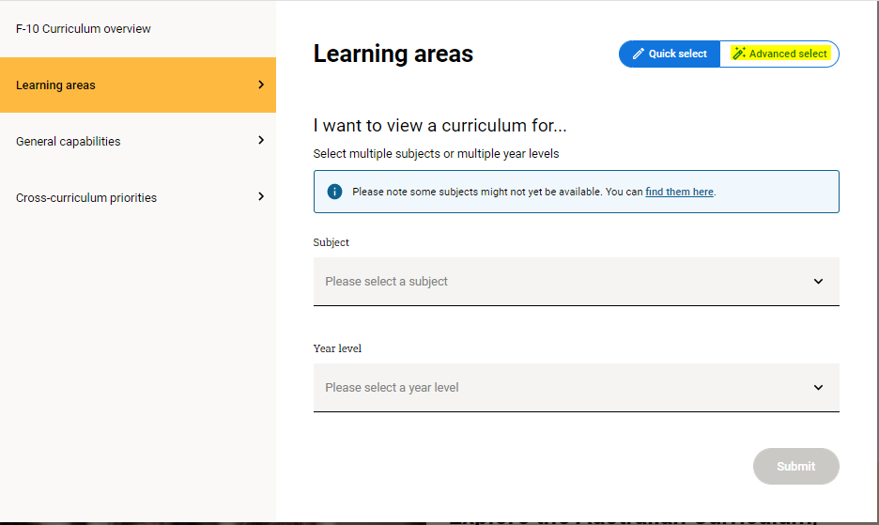
How easy was it to complete this task?
Very easy | Somewhat easy | Somewhat difficult | Very difficult
¨ | ¨ | ¨ | ¨

16. Using the Advanced select option, navigate to Science for Year 7 to Year 10, select 2 general capabilities, hide the cross-curriculum priorities and submit your selection. You should then see the curriculum content displayed with the icons for the 2 chosen general capabilities and no cross-curriculum priority icons.
Do you think this functionality will be useful for teachers?
Yes | No | Unsure
¨ | ¨ | ¨

If yes, when would you use this functionality?

17. Please let us know how you have found using the selector tool to navigate to learning areas/subjects, general capabilities and cross-curriculum priorities.

Section 6: Learning area page view
Navigate to F–10 content for Science, select all year levels and submit your selection – see screenshot below.
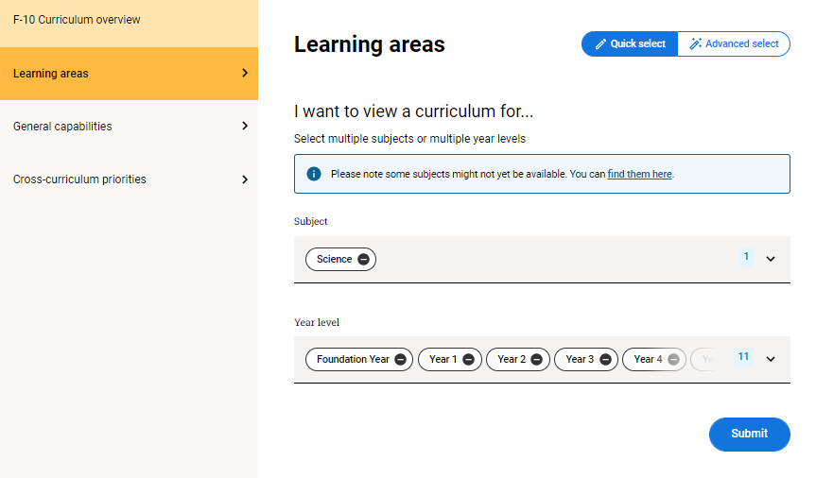

18. Now imagine you want to see the Year 8 Science curriculum. Select the option below that best describes how you went in completing this task.
It was an easy and quick task as it was intuitive. | Got there in the end, but took a while to determine the actions required. | Didn’t achieve this task, even after I tried several actions.
¨ | ¨ | ¨
Please explain your answer.

19. Select the “View single year” button – see screenshot below. This button allows you to toggle between seeing 3 year levels side by side and an individual year level.
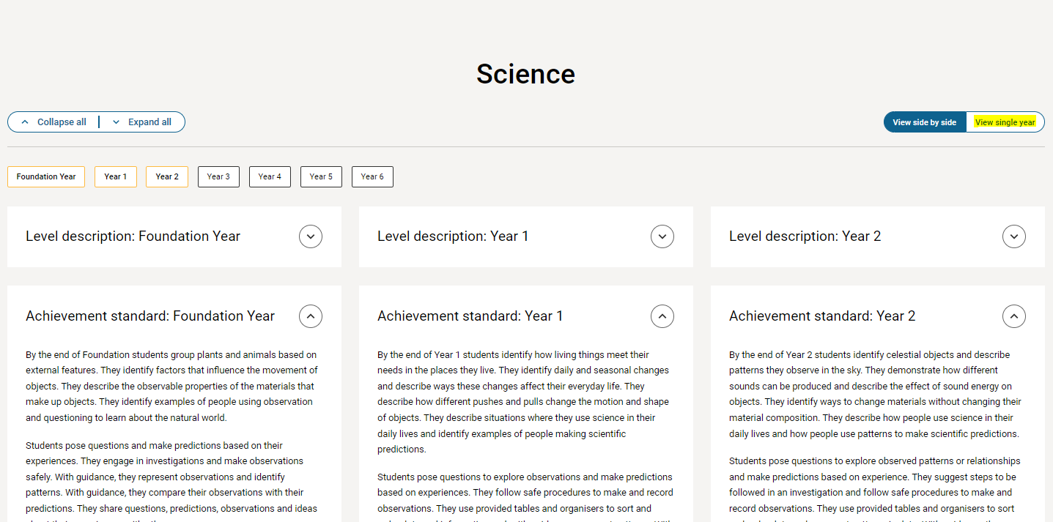
Is this functionality useful?
Very useful | Somewhat useful | Not useful
¨ | ¨ | ¨
Please explain your answer.

20. The achievement standard is displayed before the content descriptions. The achievement standard and content descriptions are fully displayed when you get to the curriculum, while the level description is collapsed.
What do you think about this layout? Select as many options as applicable from the list below.
Sends a message about what are the most important components of the curriculum to read first. | ¨
Clearly shows the connection between the achievement standard and the content descriptions. | ¨
Limits my understanding as I prefer to read the level description first. | ¨
The layout has been stripped back to make it easier to become familiar with the curriculum content. | ¨
The work samples would be better placed in the resources section of the website. | ¨
I would prefer to see the content descriptions displayed before the achievement standard. | ¨
Please add any further comments about the layout here.

21. Staying on the Science curriculum, click the sixth sentence of the Year 8 achievement standard statement: Students analyse how different factors influence development of and lead to changes in scientific knowledge" – see the screenshot below. You can then see the relationship between this statement and the content descriptions.
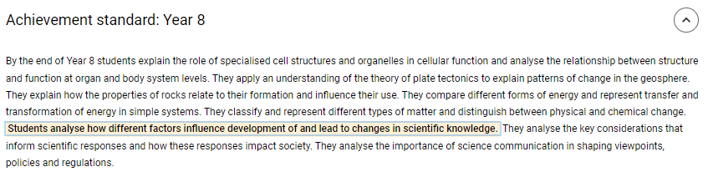
How many content descriptions are connected to this statement from the achievement standard?
1 2 3 4
22. Was it easy to see the connected content descriptions?
Yes | No
¨ | ¨

23. The default layout of content descriptions is to show the code, the content description, icons for relevant general capabilities and cross-curriculum priorities, related content if applicable, and the number of elaborations supplied – see screenshot below.
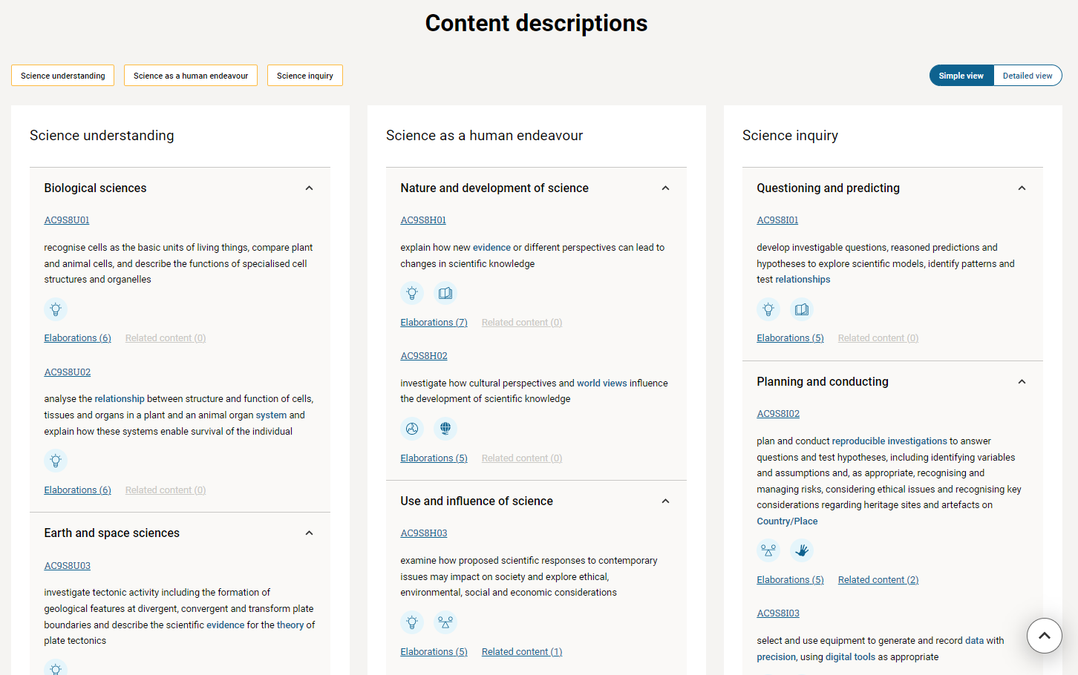
Do you like this layout?
Yes | No | Unsure
¨ | ¨ | ¨
Please explain your answer.

24. The Australian Curriculum, Version 9.0 content description codes are constructed using this standardised nomenclature:
AC9S8U01 – A (Australian) C (Curriculum) 9 (Version 9.0) S (Science) 8 (Year level) U (Strand) 01 (first content description)
How would you rate this new code structure? Please select from one star (poor) to 5 stars (excellent).

25. Staying on the Science curriculum view, click any general capability or cross-curriculum priority icon in the content description, and this will generate a slide-out with the relevant content based on your selection.
How do you rate the slide-out functionality? Please select from one star (poor) to 5 stars (excellent).

Please tell us why you gave it this rating.

26. The slide-out features navigation links on the right-hand side and provides links in general capabilities and cross-curriculum priorities, elaborations and related content (if applicable) – see screenshot below. Explore the slide-out content.
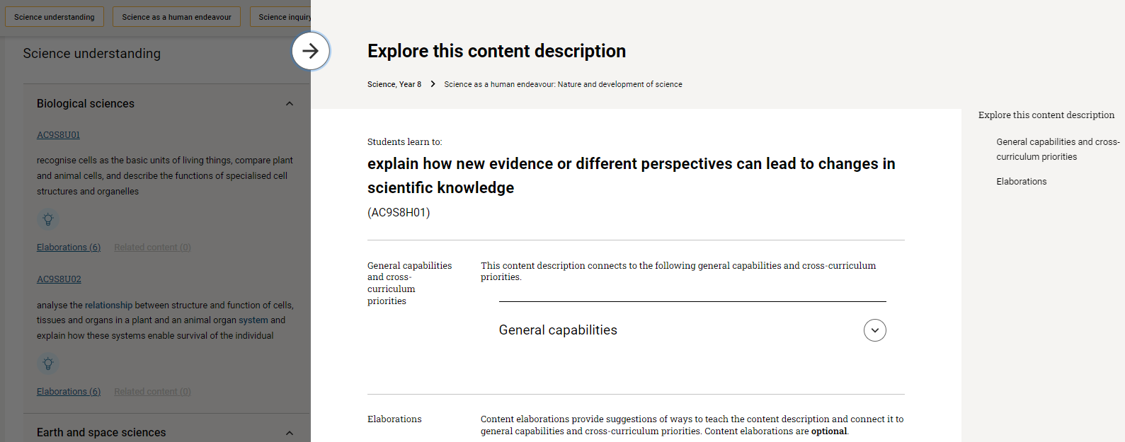
Did you find it difficult or easy to navigate the slide-out and view further content?
Very easy | Somewhat easy | Somewhat difficult | Very difficult
¨ | ¨ | ¨ | ¨
Please explain your answer.

27. Does the slide-out menu give you a clear understanding of the associated content?
Not clear | Somewhat clear | Very clear
¨ | ¨ | ¨
Please explain your answer.

28. The website function allows you to select a detailed view of the curriculum content. Staying in the Science curriculum, use the toggle to switch to a single year view, then scroll down to the content descriptions. Use the second toggle on the right-hand side to switch to detailed view. See the screenshot below to locate these buttons.
Do you prefer to view the curriculum using the simple view or the detailed view?
Simple view | Detailed view
¨ | ¨
Please explain your answer.

29. Is it easier to view elaborations using the slide-out in the simple view, or using the detailed view?
Slide-out (simple view) | Detailed view
¨ | ¨
Please explain your answer.

30. Glossary terms are displayed within the curriculum content (inline). Hover your mouse over a glossary word (shown as blue text instead of black) and there will be a pop-up with the definition. How useful is this feature?
Not useful | Somewhat useful | Very useful
¨ | ¨ | ¨

31. ACARA has provided lists of glossary words for each learning area/subject. Please find these documents on the website.
How would you rate the ease of locating this material? Please select from one star (impossible) to 5 stars (very easy).

32. Using the F–10 curriculum menu, navigate to the Digital Literacy general capability – see screenshots below. Click on a learning area icon underneath a level to open a slide-out that shows the connections to the learning area.
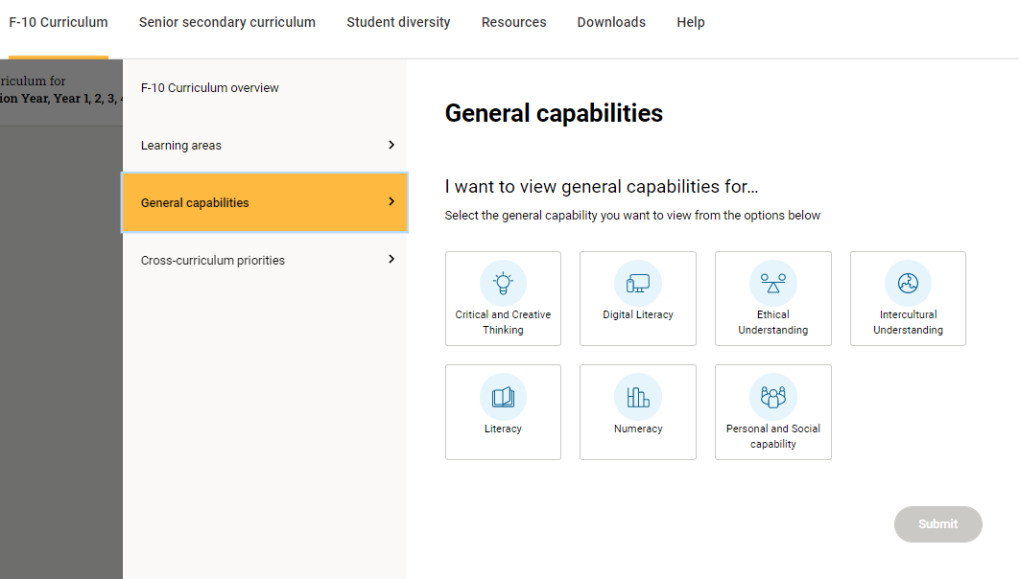
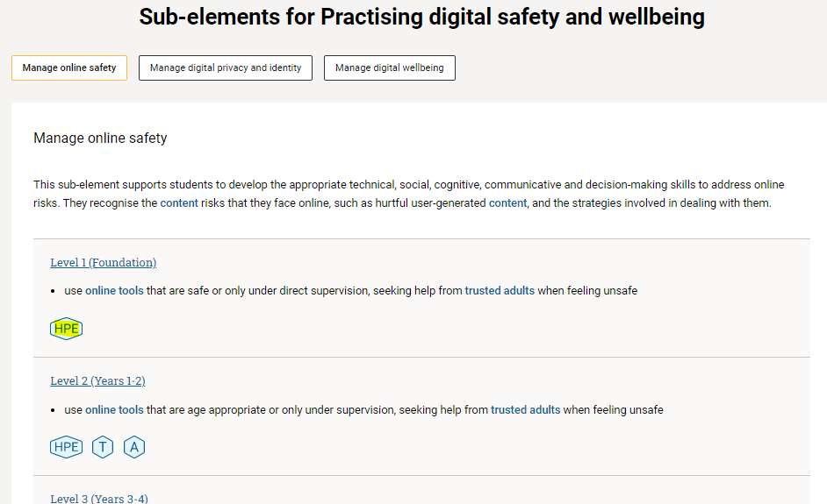
Is it valuable to be able to navigate into the curriculum via the general capabilities and cross-curriculum priorities, rather than through the learning areas?
Yes | No | Unsure
¨ | ¨ | ¨
Please explain your answer.

33. You have viewed a range of features of the website. Please take the opportunity to provide any additional feedback about these features and how they could support you to become familiar with and use the curriculum.

Section 6: Search
34. Use the search bar at the top right of the website to search for the term "movement" and click the search icon – see screenshot below.
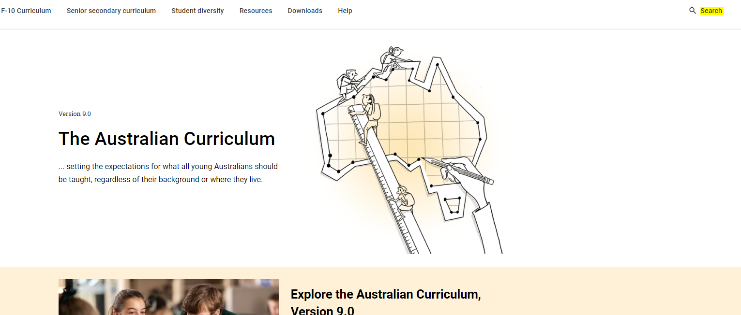
How useful and relevant did you find the search results?
Not relevant | Somewhat relevant | Very relevant
¨ | ¨ | ¨
Please provide more detail on your results and your expectations.

35. Use the filtering tool to refine your search – see screenshot below. Select Dance under Learning area, then Year 7 under Year levels. You should have 9 results all relating to Year 7 Dance.
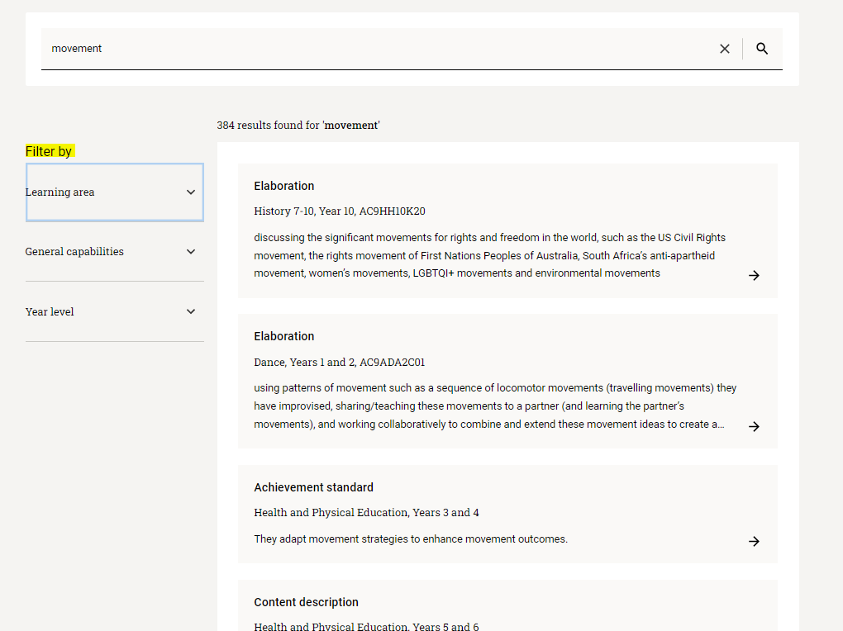
Were you able to complete this task?
Yes | No
¨ | ¨

36. How useful is the filtering tool? Please select from one star (useless) to 5 stars (very useful).

37. Please tell us your thoughts about the search function.

38. How would you rate the Australian Curriculum, Version 9.0 website overall? Please select from one star (poor) to 5 stars (excellent).

39. Having completed all the tasks in this survey that required you to use the website, please feel free to share any additional thoughts about the functions and features; for example, how you might use them, anything that surprised you or anything that frustrated you.

Section 8: Support resources
40. ACARA is currently developing resources and support material. What resources or support material would you like to see developed?

41. ACARA continues to plan future functionality and tools for the Australian Curriculum website. What features would you like to see added to the website?

Thank you for taking the time to complete this survey.

